PL-SQL Labsheet
K.Krishna Sai
AM.SC.U4AIE23124
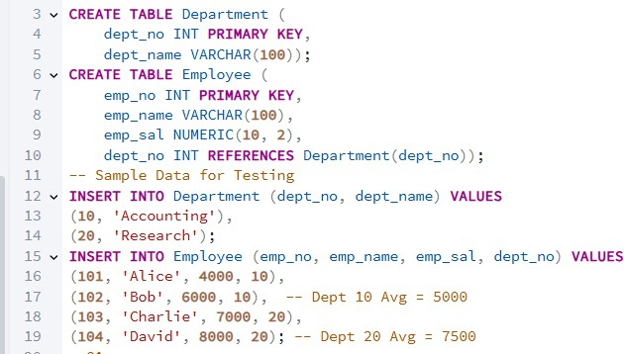
Question 1.A
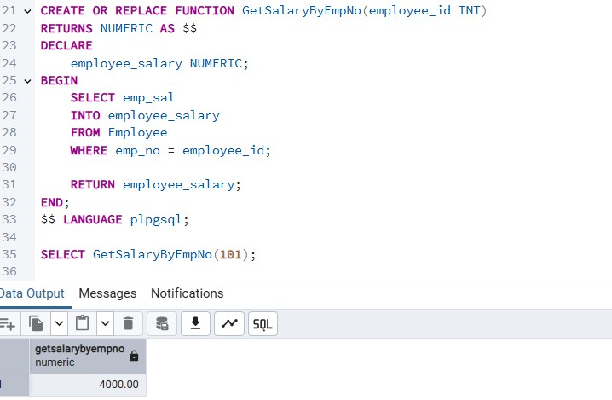
Question 1.B
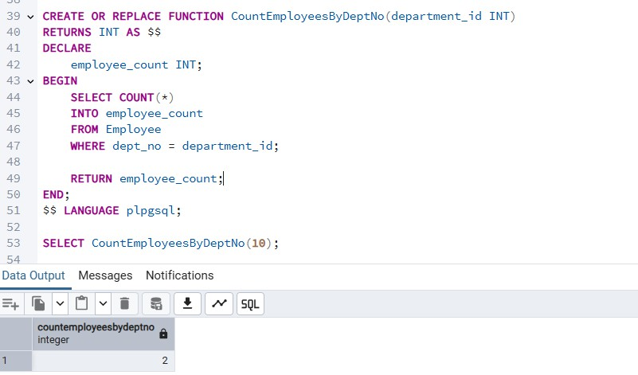
Question 1.C
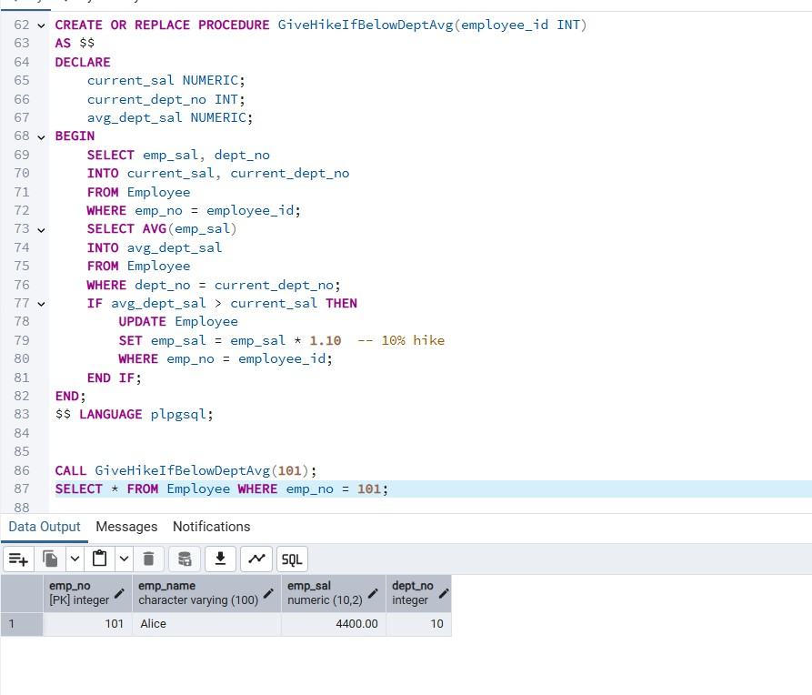

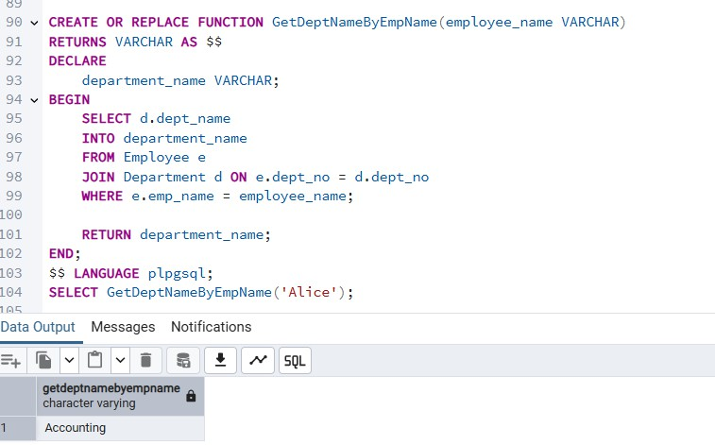

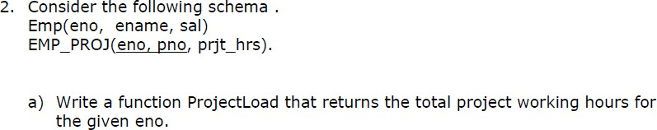
2.a
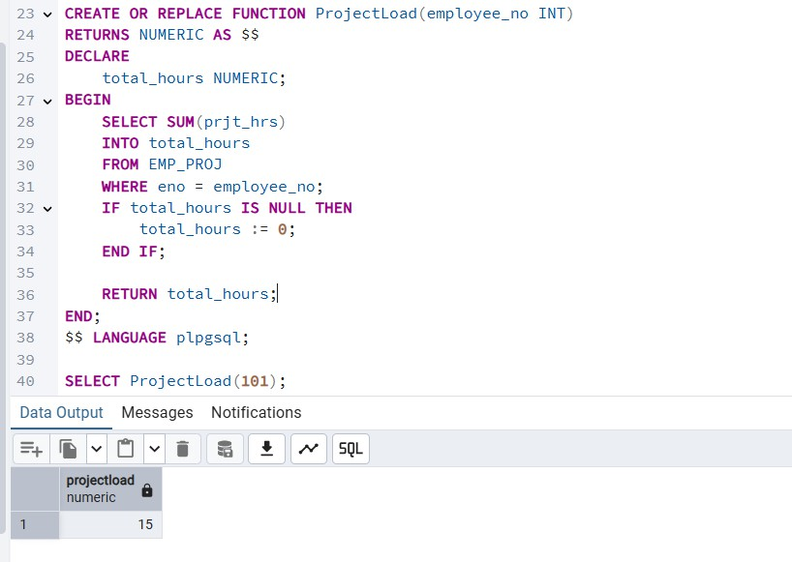

2.cWrite a PL/SQL code to update the salary of an employee if the employee earn less than the average salary.
New salary is current sal + difference between currrent sal and average salary
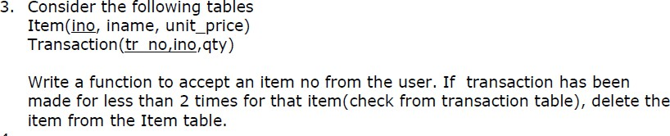
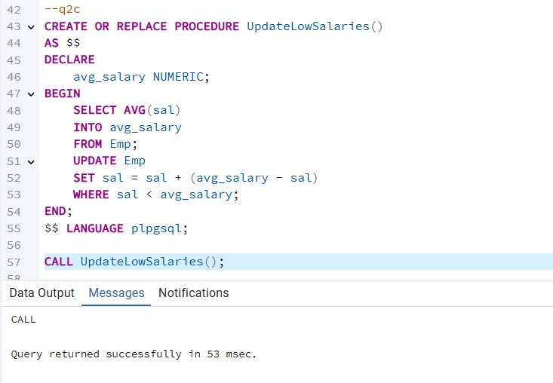
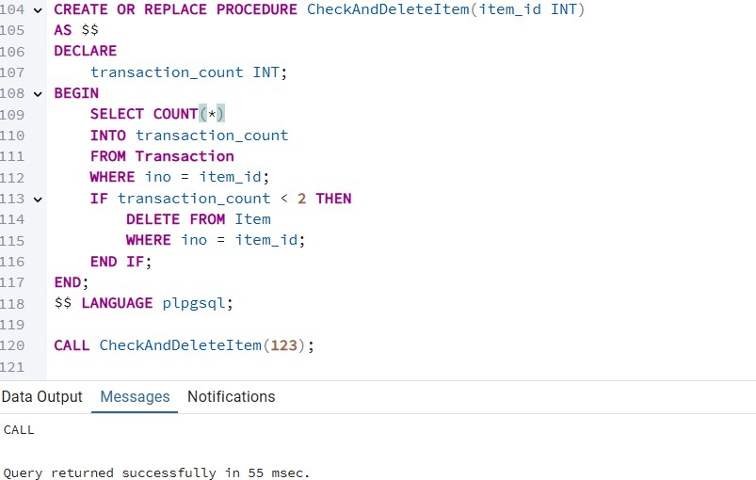

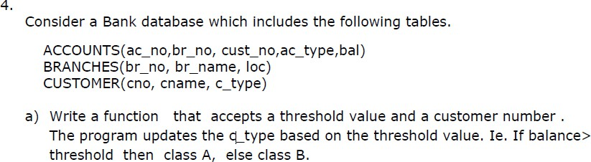
Q4A

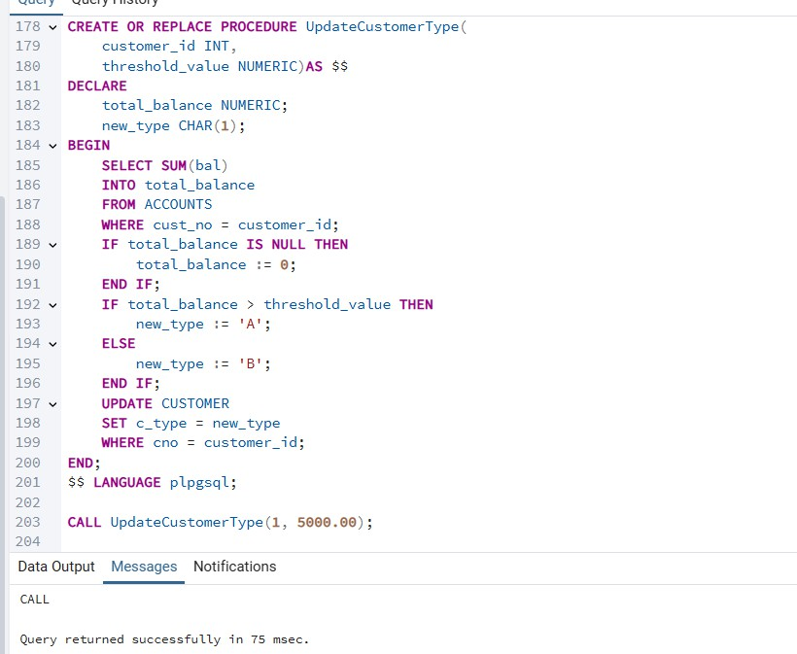

Q4B)Write a function called CloseBranch that takes two arguments (the branch to be closed and the branch to take over the accounts) and transfers all accounts at the
closing branch to the new branch and removes the closing branch.

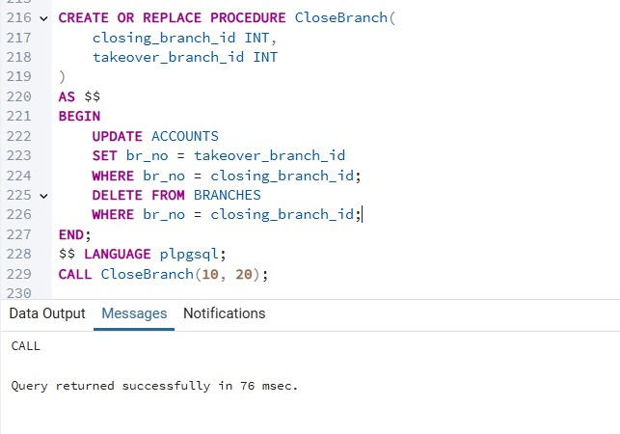
Q4C)
Write a function that implements a "safe" withdrawal operation, that only permits a withdraw if there sufficient funds in the account to cover it.

